

European Commission
Research
The Sixth Framework Programme (FP6)



A New European Technology for Cost-Efficient
and Environmentally Friendly Production of Pre-Cultivated Forest-Regeneration Materials
Contract: 32820, Call: FP6-2004-SME-


International Union of Forest Research Organizations

INNOVATION AND NEW HORIZONS IN TREE NURSERY STOCK PRODUCTION AND FOREST RESTORATION –
FROM RESEARCH TO BUSINESS

INTERNATIONAL CONFERENCE

EU FP6 Research Programme
Pre-Forest Project

Rome, Italy
March 12-14, 2009

The conference is organised in co-operation between Vivai Torsanlorenzo (Italy), Dalarna University (Sweden), Università della Tuscia (Italy), National Forest Research Institute (Greece) and IUFRO groups 3.02.00 – Stand establishment and treatment, 3.02.01 – Silvicultural operations, and 3.02.02 – Nursery operations. The Conference is organised under the patronage of the Italian Representation of the European Commission.

Target audience
More than 150 participants are expected:
- scientists from public and private forest research centres and universities;
- practitioners, forest managers and professionals from the forest sector;
- members of non-governmental organisations involved in the forest sector;
- students in forestry and ecology.

Background and objectives
In the last decade considerable changes have occurred in tree forest nursery techniques (from seed handling and processing to planting stock storage) and in forest restoration operations. Main drivers of change are represented by the implementation of sustainable forestry with focus on biodiversity, landscape and climate change, the need to reduce resources—such as fertilisers, pesticides, peat, water, energy—imputed during plant production. This is because of environmental as well as economic reasons. Contemporary forest restoration is a complex task, as it assumes different forms according to diverse ecological, socio-political and historic contexts. Wild and urban foresters have to face particular challenge to harsh growing conditions, diseases, and insects. Forest restoration is under way in order to counteract the negative effects of human activities and it is asked to maintain or enhance bio-diversity, mitigate climate change, repair ecosystem functions. Thus, appropriate silvicultural operations can be designed for any forest restoration objective. Yet, forest restoration requires creativity, flexibility in applying silvicultural tools. Also a pragmatic approach is needed, as costs of restoration and scale of degradation are constraints.
Technical innovation and forethought are needed to adapt forest nursery management and forest restoration to this context. Collaboration between forest research and business on a national and trans-national level is needed to build up or enhance the research capacity of enterprises, to generate new knowledge, to transfer technology, to access to venture capital or business and innovation support services, to to engage in commercial activities.
This conference intends to be the the venue where scientists, forest managers, policy advisors in forestry and private nursery entrepreneurs and producers of nursery equipment, have the opportunity to:
- display the results of research activities and prototypes, innovative biological results and technical solutions regarding nursery management and forest restoration, especially in difficult sites;
- to present new ideas for technological innovation, prototypes and applications to be marketed for businesses, and discuss future development within this area.

During the conference the results of a two-year research project named “PreForest”, funded by the European Commission, within the VI Research Framework Programme, Cooperative Research Action For Technology (CRAFT), will be presented.

EC CRAFT programme allows small and medium enterprises to create consortia with research organisations and to formulate highly innovating initiatives, whose results are easily e rapidly useable by the enterprises involved in the project as well as the others operating in the sector.

Two themes will thus be developed at the conference:
- Innovative forest nursery management
- Contemporary forest restoration

Conference format

The conference will extend over three days and will comprise oral presentation session, poster session and field session.

Oral presentation session
The oral presentation session will cover two days, starting Thursday at 9:30 and runs through Friday afternoon. In each day, this session will comprise three thirty-minutes key-note speeches given by authoritative scientists, followed by twenty-minute presentations (see the Programme section here below). This session is comprised of individuals who have submitted an abstract reflecting the conference themes. Speakers will be expected to answer moderator's and audience questions regarding a position or statement of their paper.

Poster session
Poster sessions will an integral part of the program the conference “Innovation and new horizons in tree nursery stock production and forest restoration – from research to business” INNOFORA). Thus, as a poster presenter, you are kindly invited to discuss the topic and to give informal presentation of your work to interested peers.
That’s why we have strongly encouraged scientists and graduate students to use this opportunity to present their work at an international conference. The Scientific Committee will go to the poster that best reflects the conference theme. An award that is judged on the basis of the most votes cast by the conference participants will be assigned. Selection of posters has been based on the submission of an abstract.
An appropriate facility will be provided for the setting up and presentation of posters, and conference participants will be encouraged to attend the poster sessions. The poster sessions will be housed in a large meeting room (close to the dining area, so that a good audience is assured!), filled with poster-boards (type moveable Snap Frame Poster Board). Each poster-board will be able to accommodate poster not larger than 100 x 70 cm (6 feet high and 4 feet wide), portrait format, height x width.
The organizers will provide you assistance and instructions to set up your poster when you register. You are asked to mount your poster by 9am on Thursday 12th March or as soon as possible afterwards and to present your poster from 11:00- to 11:30, and from 15:00 to 15:30 the 12 and the 13th of march and from 17:30 to 18:30 the 13th of March.
Titles and abstracts will be also printed in the proceedings of the conference.
Projectors will not be available and cannot be used in the poster area. However, there may be video presentations if the author supplies the equipment. If the work presented in the poster has been described in more detail in a paper, consider making the paper available as a handout at the poster session.

Field session
The third day will be devoted to the a visit at Torsanlorenzo nurseries, Via Campo di Carne 51, 00040, Tor San Lorenzo - Ardea (RM). At the field visit, the results of a the “PreForest” project, funded by the European Commission within the VI Research Framework Programme will be presented by the research leaders of the project. The visit will be an opportunity to see one of the three robot prototypes shaped by “Preforest” (the other two are located in Greece and Sweden), an innovative technology for production of forest regeneration material in a cost efficient and environmental friendly production unit.
The nursery will be reached by train (from Termini station). The organisers opted for train as mean to get to Vivai Torsanlorenzo, since it much faster than coach (and more environmentally sustainable!). It does take only 38 minutes to get from Rome Termini station to Campo di Carne and costs Euros 5.4 (return). A shuttle provided by the organisers will connect Campo di Carne station to the nursery. A brunch will be served at the nursery. Detailed information on the visit will be given by the organizers the first day of the conference.

Programme

Day 1 – Thursday 12/3

8:30 to 9:30 - Registration

9:30 - Opening of the Conference

Welcome
Vincenzo Spadafora, Unicef Italy, President
Elisabetta Margheriti, Vivai Torsanlorenzo, coordinator of the Pre-Forest Project

Theme 1: Innovative forest nursery management

Oral presentation and poster session

Chairperson
Lorenzo Ciccarese, ISPRA- Italian Institute for Environmental Protection and Research, Italy

Why improving ties between research & forest tree nurseries is important
Steve Colombo, Ontario Forest Research Institute, Canada

Research innovations to support plant quality assessment within forest nursery management
Anders Mattsson, Dalarna University

11:00-11:30 - Coffee break and poster session

Innovative forest nursery management - business based on research
Erik Normark, Holmen Skog, Sweden

Innovation in forest seed management
Beti Piotto, ISPRA, Italy

Forest planting stock material in Greece: introduction of a new production technology in mini-plugs
Kalliopi Radoglou, NAGREF, Greece

13:00-14:00 - Lunch

Enhancing seed germination in broadleaf species in bare root nurseries
Conor O'Reilly, University College Dublin, Ireland

Designing seedling morphology using new technological tools
Maria Helena Almeida, University of Lisbon, Portugal

Jiffy and Preforma: propagation of forest and Mediterranean plants
Lars-Ove Sandberg and Anno Hermes, Jiffy Products International

15:30-16:00 - Coffee break and poster session

Pre-Forest: a new technology for large scale production of pre-cultivated forest regeneration materials
Elisabetta Margheriti, Vivai Torsanlorenzo, Italy

Testing different origins to determine the effects of stratification on germination in production of rowan (Sorbus aucuparia L. ) from seed
Banu Bekci, KTÜ University, Turkey

Hydroponic nursery production in Azorean endemic species- Prunus azorica
Anabela Isidoro, Regional Forest Service, Portugal

Modern nursery practises at Alba Trees
Rodney Shearer, Alba Trees, UK

The Eu Directive on forest reproductive material: implementation in Italy
Lucia Contri, Regione Emilia Romagna, Italy

17:30 – 18:00 Discussion and remarks

20:00 – Official dinner

Day 2 - Friday 13/3

9:00 – Resume of the Conference

Theme 2: Contemporary forest restoration

Chairperson
Annalisa Ceccarelli, APRE – Italian Agency for Promotion of European Research, Italy

Contemporary forest restoration: socially acceptable and sustainable solutions
John Stanturf, Forest Service, USA

Planted forests: status, trends and outlook. Guidelines for responsible management
Alberto Del Lungo and Jim Carle, UN Food and Agriculture Organization

Sustainable forest management and voluntary standards for afforestation and reforestation
Davide Pettenella, University of Padua, Italy

11:00-11:30 - Coffee break and poster session

Innovations in afforestation of agricultural bottomlands to restore native forests in the United States
Daniel C. Dey, Forest Service, USA

Forest landscape restoration in Mediterranean cork oak landscapes: building capacity & partnerships
Nora Berrahmouni, Mediterranean Programme Office, WWF

An economical and compact experimental design to evaluate restoration treatments
John-Pascal Berrill, Humboldt State University, CA, USA

13:00-14:00 - Lunch

Azorean endemic forest: the importance of a legacy: a project for the future
Josè Mendes, Regional Directorate of Forest Resources, Portugal

Seed quality of Siberian larch (Larix sibirica Ldb.) and Scots pine (Pinus sylvestris L.) from geographically diverse seed sources of Mongolia
Batkhuu Nyam-Osor, , National University of Mongolia

15:00-15:30 - Coffee break and poster session

The JIP-test: a tool to screen plant vitality. Application and potentiality in tree growing
Filippo Bussotti, University of Florence, Italy

New approaches concerning forest restoration in a protected area of Central Italy.
Roberto Mercurio, Mediterranean University, Italy

Effectiveness of Miyawaki method in Mediterranean reforestation programmes Bartolomeo Schirone, Tuscia University, Italy

Forest resources for biofuels production in the Apennines
Alessio Papini, University of Florence, and Marco Cosimo Simeone, Tuscia University, Italy

17:00–17:30 Discussion and remarks

17:30-18:00 - Sessions and conference syntheses

18:00– Closing

Day 3 - Saturday 14/3

Field session

Visit at Torsanlorenzo nurseries, Via Campo di Carne 51, 00040, Tor San Lorenzo - Ardea (RM). At the field visit, the results of the “PreForest” project, funded by the European Commission within the VI Research Framework Programme will be presented by the research leaders of the project. The visit will be an opportunity to see one of the three robot prototypes shaped by “Preforest” (the other two are located in Greece and Sweden), an innovative technology for production of forest regeneration material in a cost efficient and environmental friendly production unit.
The nursery will be reached by train (from Termini station). The organisers opted for train as mean to get to Vivai Torsanlorenzo, since it is much faster than coach (and more environmentally sustainable!). It does take only 38 minutes to get from Rome Termini station to Campo di Carne and costs Euros 5.4 (return). A shuttle provided by the organisers will connect Campo di Carne station to the nursery. A brunch will be served at the nursery. Detailed information on the visit will be given by the organizers the first day of the conference.

Venue
The conference will take place in Rome centre, at the Auditorium of UNICEF, Via Palestro 68, located near the main railway station in Rome “Roma Termini”.

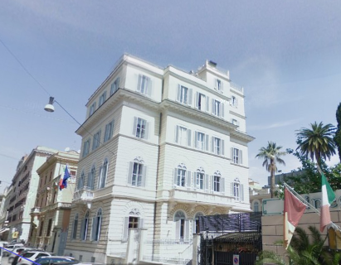

Rome is served by two international airports: “Leonardo da Vinci” and “Ciampino”. From “Leonardo da Vinci” airport it is possible to get by train to “Roma Termini” in approximately 30 minutes. Ticket costs 11.00 Euros and can be purchased at the terminal of the airport. Service runs every 30 minutes.
From “Ciampino” airport it is possible to get to “Roma Termini” by shuttle, provided by the air companies. Ticket costs approximately 8.00 Euros and can be purchased at the terminal of the airport.
“Roma Termini” railway station, on the way to Via Marsala, is about 300 m far away from the conference venue, 4 minutes by walking (see map below).

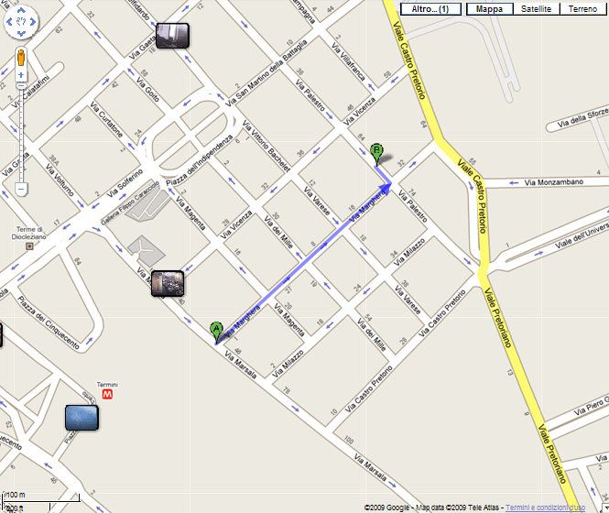

From “Termini” railway and underground station (line A and B) to the Conference Venue

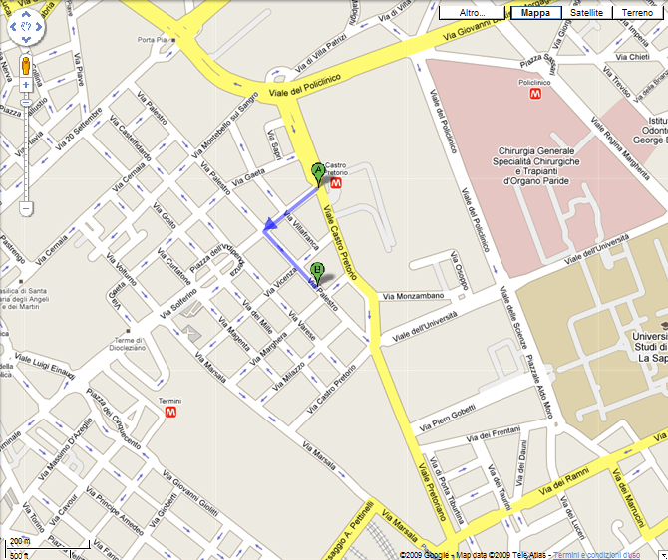

From “Castro Pretorio” underground station (line B) to the Conference Venue

By underground, the nearest tube stations to the Conference Venue are “Termini” station, line A and B; and “Castro Pretorio” station, line B.
By bus, the nearest bus stop to the Conference Venue is Piazza Indipendenza, served by several lines: 75, 86, 92, 217, 360, 38, 649, 310, M, 16, 40, 92, 105, 170.

For information about the city of Rome view the web sites at www.060608.it, www.comune.roma.it, www.wantedinrome.it.

The weather in Rome in March tends to be just right as the sun is often shining and the temperature has heated up enough from the winter months. Average weather per March is: low temperature: 7 °C; high temperature: 15 °C; a.m. humidity: 83; p.m. humidity: 56; rainfall: 57 mm; sunshine: 6 hrs.

Hotel reservation and additional information
Conference participants are kindly requested to make their own hotel reservations. Please consult the website www.060608.it for more information.

Weather
The weather in Rome in March tends to be just right as the sun is often shining and the temperature has heated up enough from the winter months. Average weather per March is: low temperature: 7 °C; high temperature: 15 °C; a.m. humidity: 83; p.m. humidity: 56; rainfall: 57 mm; sunshine: 6 hrs.

Currency / Banks/ Credit Cards.
The local currency is EURO. There are several banks located around the conference site. Money can also be exchanged at the airport and the “Termini” railway station. Credit cards are generally accepted by hotels, restaurants and most department stores and shops. However, small shops and cafés prefer cash.

Restaurants and cafés.
There are many restaurants and cafés in the neighbourhood of the conference site. We will provide you with a list of restaurants and cafés located near the congress site at the time of registration.

Shopping Hours
Shops are usually open from 09:00 to 19:30 (also on Saturday). On Sunday some shops are open. On Monday morning, some shop are closed.

Italian Electric Plugs
Italian electric power voltage is 230V and frequency is 50 Hz. For more details please see the following link: www.kropla.com/electric2.htm

Assistance and information
For further assistance you may contact:

Dr Elisabetta Margheriti
Vivai Torsanlorenzo
Via Campo di Carne 51
00040, Tor San Lorenzo - Ardea (RM)
Tel.: 0039 06 91019005
Fax: 0033 06 91011602
E-mail: emargheriti@vivaitorsanlorenzo.it

or

Dr Marco Simeone
Environment and Forest Department (DAF)
Università degli Studi della Tuscia
Via S. Camillo de Lellis
011000 Viterbo
Italy
Tel.: 0039 0761 357411 / 391
Fax: 0039 0761 357250
E-mail: mcsimeone@unitus.it

or

visit the website www.vivaitorsanlorenzo.it/preforest.htm , www.preforest.eu

Registration
Registration is free of charge. A fee is requested for the official dinner (about 30 €). For registration, please fill the registration form.

Call for oral and poster presentations
Participants are deeply invited to submit voluntary contributions either as oral or poster presentations. The scientific committee will select 16 appropriate oral presentations. Due to this limitation some authors will perhaps be asked to convert their suggested oral presentations into posters. Please note that the deadline for receipt of abstracts of oral and poster presentations is February 16th, 2009.
The abstract outlines the aims and content of the presentation and should not exceed a length of 400 words.
It should be clear whether it is for an oral presentation or a poster. It has to be submitted electronically by mail or by fax to
Dr Elisabetta Margheriti, e-mail: emargheriti@vivaitorsanlorenzo.it, fax 0039 06 91011602

or

Dr Marco Simeone, e-mail: mcsimeone@unitus.it, fax: 0039 0761 357250
Posters should be in A0 portrait format (841 mm x 1189 mm).
Presenters will need to have registered for the Conference for their abstracts to be definitively accepted.
Authors will be notified by 20th of February at the latest of acceptance or rejection of their contribution as oral or poster presentation.
Oral presentations are limited to 20 minutes.

Organising committee
Rosanna Bellarosa (Italy), Lorenzo Ciccarese (Italy), Fernando Clerici (Argentina), Raquel Ferreira (Portugal), Elisabetta Margheriti (Italy), Anders Mattsson (Sweden), Carlo Polidori (Belgium), Marco Simeone (Italy).

Scientific committee
Helena Almeida (Portugal), Alberto Del Lungo (FAO), Lorenzo Ciccarese (Italy), Anders Mattsson (Sweden), Roberto Mercurio (Italy), Connor O’ Reilly (Ireland), Kalliopi Radoglou (Greece), Bartolomeo Schirone (Italy).

Proceedings

Proceedings of abstracts of selected oral or poster presentations will be edited at the conference. The Proceedings will be published after peer review. A selection of the papers and posters presented at the conference will be published in a special issue of Scandinavian Journal of Forest Research. Instructions for Authors are available at http://www.tandf.co.uk/journals/authors/sforauth.asp

Official language
The language during the sessions will be English.
Registration form
INNOVATION AND NEW HORIZONS IN TREE NURSERY STOCK PRODUCTION
AND FOREST RESTORATION – FROM RESEARCH TO BUSINESS
Rome, Italy
March 12-14, 2009

You are kindly invited to send this registration form by e-mail or fax to:
Dr Elisabetta Margheriti
E-mail: emargheriti@vivaitorsanlorenzo.it
Fax: 0039 06 91011602
or
Dr Marco Simeone
E-mail: mcsimeone@unitus.it
Fax: 00339 0761 357250

Title______________________________________________________________________

First name________________________________________________________________

Family name_______________________________________________________________

Organisation_______________________________________________________________

__________________________________________________________________________

Postal address_____________________________________________________________

_________________________________________________________________________

_________________________________________________________________________

Tel. country code_____________ Number_____________________________________

Fax ______________________________________________________________________

E-mail ____________________________________________________________________

Web address_______________________________________________________________

Participation to the official dinner
Yes | No

Participation to the field session
Yes | No

INNOVATION AND NEW HORIZONS IN TREE NURSERY STOCK PRODUCTION
AND FOREST RESTORATION –
FROM RESEARCH TO BUSINESS

INTERNATIONAL CONFERENCE

Rome, Italy
March 12-14, 2009

Call for oral or poster presentations for the EU-IUFRO International Conference 2008
[To be returned to
emargheriti@vivaitorsanlorenzo.it, or by fax to 0039 06 91011602
or
mcsimeone@unitus.it, or by fax to 00339 0761 357250]
Title:
Preference: |  | Oral presentation | Poster
Theme(s) : |  | Innovative forest nursery management  Contemporary forest restoration
Authors:
 | Title First name SURNAME | Organisation | Country | Email
1:
2:
3:

Abstract (maximum 400 words):

